Progress Report on Fusarium-Sugar Beet Interactions.

Dr. Linda E. Hanson, USDA-ARS
Sugar Beet Research Unit
Fort Collins, CO
Dr. Barry Jacobsen, Montana State University
Bozeman, MT

Background: Fusarium yellows of sugar beet (caused by the fungus Fusarium oxysporum f.sp. betae) can cause significant reductions in root yield, sucrose percentage, and juice purity in affected sugar beets (Schneider & Whitney 1986). Fusarium accuminatum also has been reported to cause yellows symptoms (Ruppel 1991). In addition, isolates of F. oxysporum (Martyn et al. 1989), F. culmorum (Hull 1960), and F. solani (Abada 1994) have been reported to cause root rot of sugar beet.
In a number of Fusarium oxysporum formae speciales there are races that differ in their virulence on different cultivars of the host (for example at least seven pathogenic race of F. oxysporum f. sp. phaseoli are known on dry bean). We have found preliminary evidence that differences in virulence of F. oxysporum f. sp. betae may occur on different sugar beet host cultivars when we observed that, while on several sugar beet cultivars (Fig. 1), isolate FOB 216c was more virulent than FOB 13, but on other sugar beet cultivars, virulence of the two isolates was similar or FOB 13 was more virulent than FOB 216c.
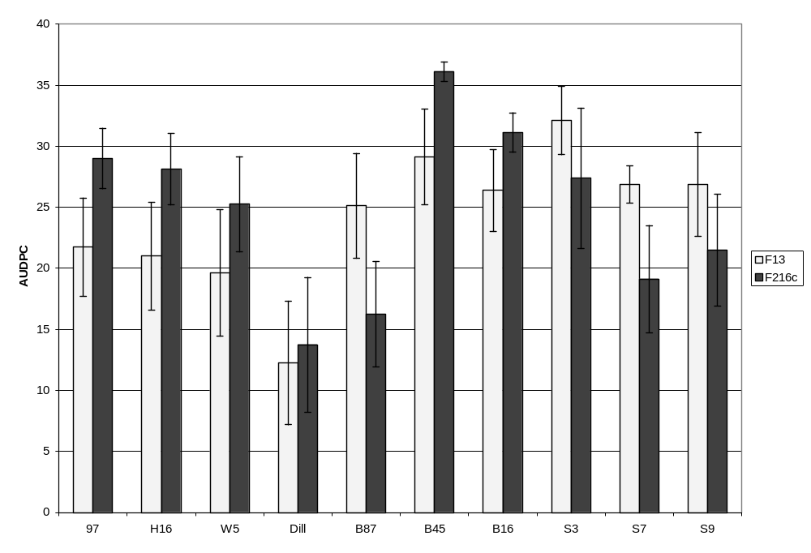
Figure 1. Disease response of 10 sugar beet cultivars to two different Fusarium oxysporum f. sp. betae isolates at moderate temperature shown as average area under the disease progress curve (AUDPC).

Growers have found differences in how well sugar beet with host resistance works in different areas. Based on this and the variability found in FOB it is hypothesized that there are races in this forma specialis. An improved method of screening for resistance and better understanding of the interaction between sugar beet lines and FOB isolates is needed.

Progress: Sugar beet that has been reported to vary in resistance to FOB in different tests, as well as lines believed to be susceptible and resistant to several FOB have been generously provided by KWS, Syngenta, and Seedex.
Five different FOB isolates from different geographic regions and that show genetic variability were grown at both Montana State University and the USDA-ARS Sugar Beet Research Unit in Fort Collins, CO. Isolates are Flynn, Hardin, Fob13, F19, and F216c. In addition, isolate Fo37 was tested in CO and isolates Fo24, 25, and 28 were tested in MT. These isolates are from MT, OR, CO, and MN.
Pathogenicity tests are carried out on 20 sugar beet lines. Briefly, sugar beets are grown for 5 weeks. Beets are removed from the soil; the roots are soaked in a spore suspension (approximately 10⁴/ml) of F. oxysporum for 8 min. Plants are replanted into pasteurized potting mix. Five plants are used per pot in 10” pots, two pots per treatment. Plants are fertilized with Osmacote and watered every two days. The number of plants in each pot that are dead is counted each week for six weeks. In addition, in CO, plants are rated weekly for six weeks for symptoms using a scale of 0-5 0 to 5 where 0 = no visible disease and 5 = death of the entire plant for statistical analysis. Plants are tested at moderate temperatures (approximately 28C day time temperature).
. An example of the variability in responses is shown for four of the isolates with the 20 sugar beet lines in Fig. 2.

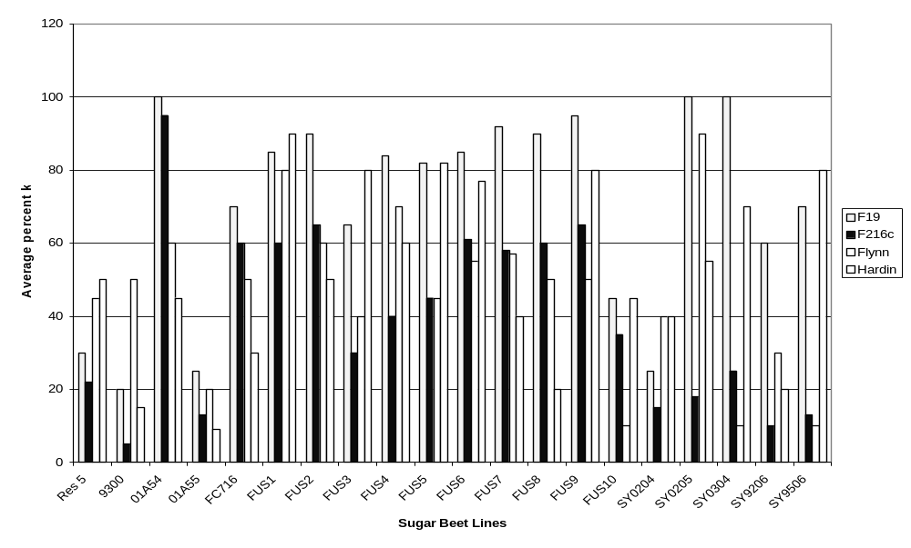

Figure 2. Response of different sugar beet lines to four different isolates of Fusarium oxysporum f.sp. betae. Shown is the average percent of plants killed by four weeks after inoculation for 10 plants in each experiment of each line exposed to the isolates. Results are the average of results from the Colorado and Montana tests.

Statistical analyses are performed with the PROC MIXED procedure in SAS. Mean separations were conducted using the macro PDMIX800.SAS with Tukey’s adjustments to control the type I error rate. One line showed no evidence of reduced sensitivity to any of the isolates tested, but for each of the other sugar beet lines, disease severity (as AUDPC) was significantly lower than the most susceptible line for at least one isolate. However, no line showed significantly reduced sensitivity to all isolates. Four lines did show generally low levels of disease, but most of these showed no significant reduction in disease (compared to the susceptible control) for at least one of the FOB isolates. None of the sugar beet lines were completely resistant to all isolates; that is, not significantly different from the uninoculated control for all isolates.

